Access RDS DB deployed in Private server using MySql Workbench
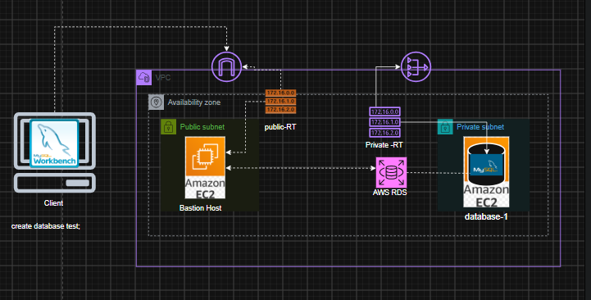
Task -1
Deploy a database using AWS RDS on a private server and communicate with database using MySql Workbench.(Here we are using free tier , so will be using Single-AZ DB instance deployment (1 instance) , we can also use Multi-AZ DB cluster deployment (3 instances) , and Multi-AZ DB instance deployment (2 instances) )
Prerequisite :-
- VPC and More (1 az ,1 public ,1 private subnet , NAT – required, PVC endpoint – not required).
- create one database In created vpc bye selecting private subnet (access type private) .
- Create a Bastion host in public subnet(with private key , SG-all traffic ,anywhere).
- Configure MySql workbench (MySql workbench ->Bastion host->private database).

Steps –
- Create vpc . 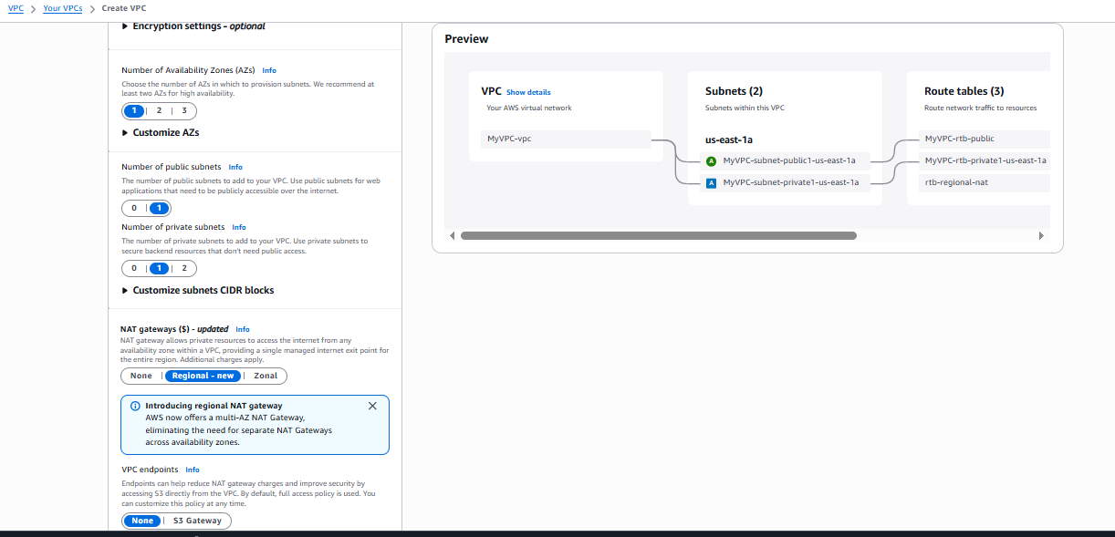
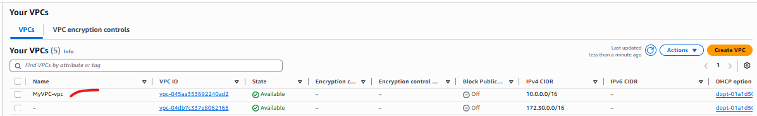

- Create database , Select - Single-AZ DB instance deployment (1 instance).

DB instant identifier – database-1
Master user name – admin
Credential management – self managed
Instance type – t3micro
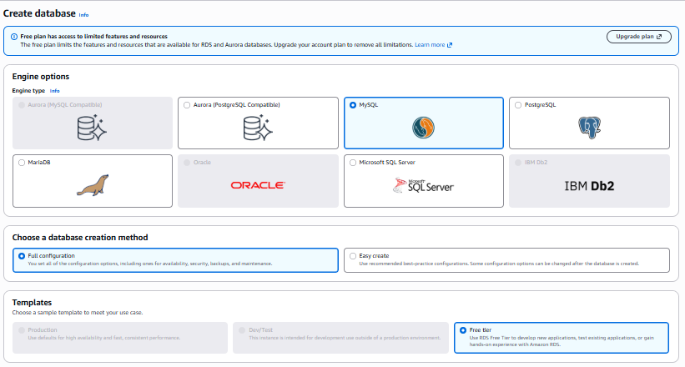
- Chose VPC
- Chose subnet group (We need to create subnet group to indicate where our replica we want RDS to deploy)

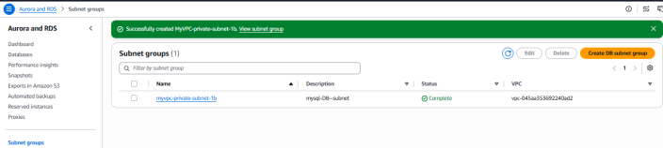
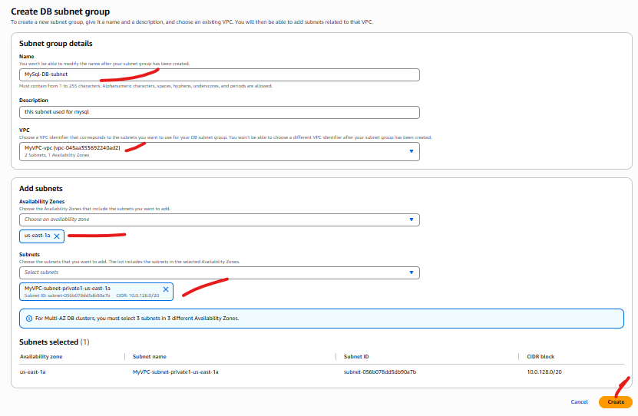

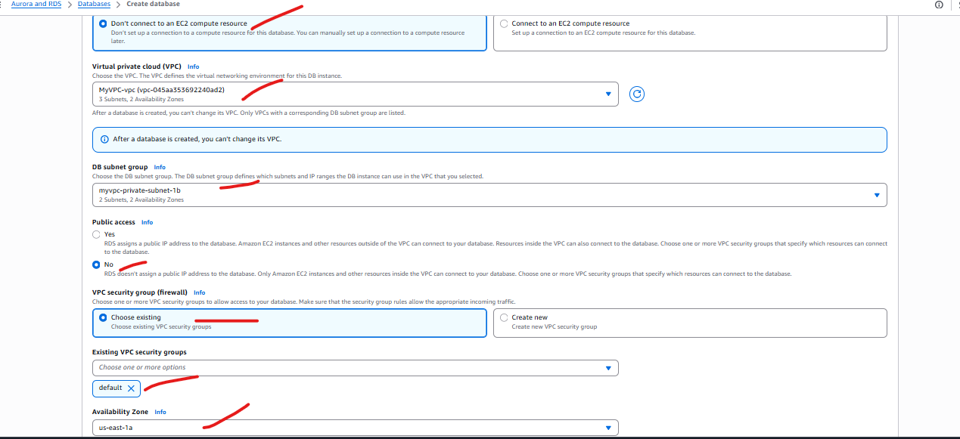

Select SG – allow inbound for 3306 port for vpc connection .
Availability zone – select in which zone you want to deploy your db
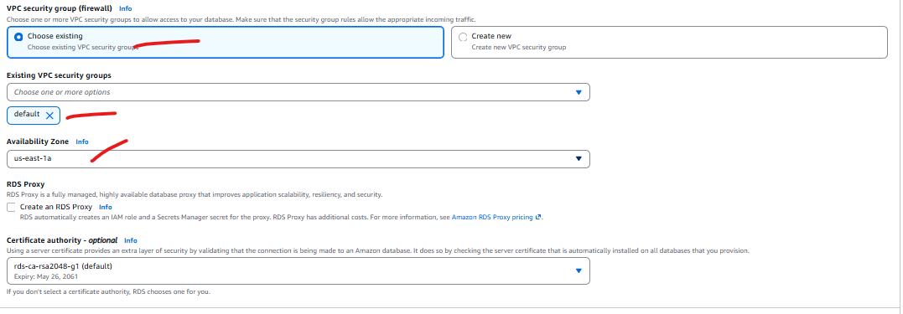

Then create database. It will take some time
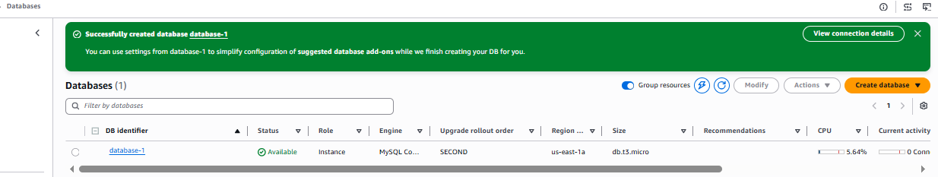

- Create a Bastion host in public subnet(with private key , SG-all traffic ,anywhere).
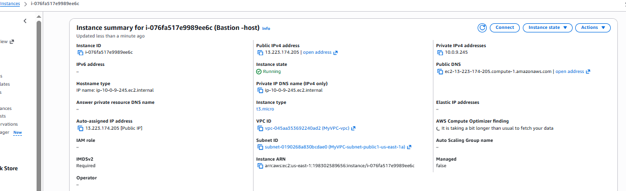

- Configure MySql workbench (MySql workbench ->Bastion host->private database).
Select TCP/IP over SSH

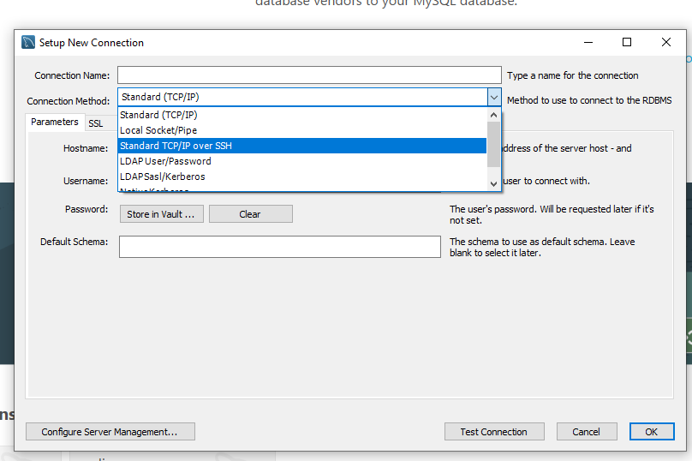

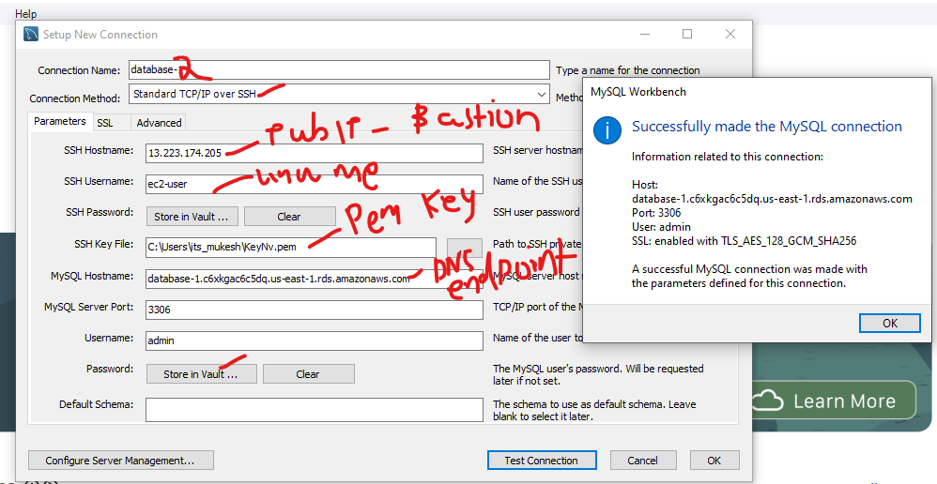
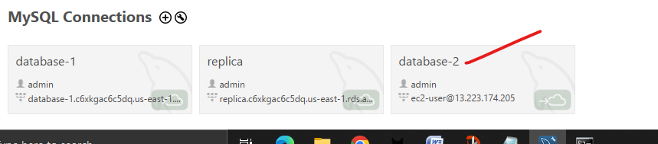

Now make connection and create database name test –
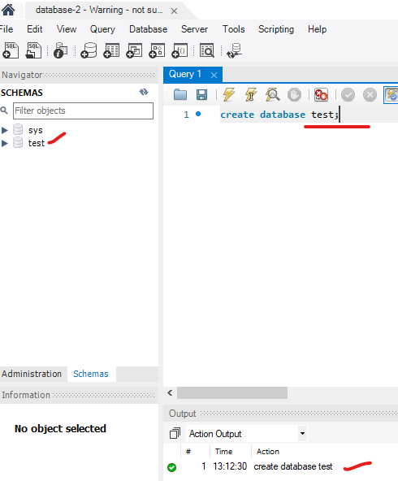

Lab Over

